***Lost in the Woods, the 1945 Crash Site of a Navy Hero***

**By**[**COREY KILGANNON**](https://www.nytimes.com/by/corey-kilgannon) July 25, 2017

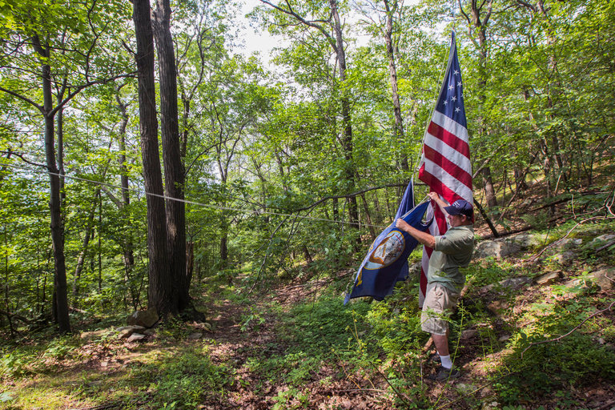

Dave Rocco on Mount Beacon at the site where a Navy transport plane crashed in 1945, killing all six servicemen aboard.

CreditHirokoMasuike/The New York Times

FISHKILL, N.Y. — Clutching a bundle of American flags to his chest, Dave Rocco made his way up Mount Beacon, battling through the 90-degree heat and pain from his titanium knees.

Mr. Rocco, 60, negotiated the rocky path blazed 72 years ago by rescuers who hacked their way up the mountain following a plane crash some 1,100 feet up in the Hudson Highlands, a few miles east of Beacon, N.Y., a 75-minute drive north of New York City.

Mr. Rocco hopes to turn the rocky passage into a path of recognition to the place where a Navy transport plane [went down in the rain and fog](https://timesmachine.nytimes.com/timesmachine/1945/11/13/305806942.html?pageNumber=36) on Nov. 11, 1945, killing all six servicemen aboard.

“You can still see the scorched earth — it’s still bare after 72 years,” Mr. Rocco said of the crash site, which with some scattered wreckage was still visible on the forest floor along Fishkill Ridge.

Mr. Rocco and some friends have been hiking to this wooded spot in recent years to tend it as a memorial to the victims, who included Commodore Dixie Kiefer, 49, a decorated Naval hero who served in both world wars.

Commodore Kiefer emerged as one of the most famous commanders in [World War II](http://topics.nytimes.com/top/reference/timestopics/subjects/w/world_war_ii_/index.html?inline=nyt-classifier), and received the Distinguished Service Medal from the Secretary of the Navy, James V. Forrestal, a Beacon native who nicknamed Commodore Kiefer “the indestructible man,” for his having survived close brushes with death in battle.

A few months after receiving the award, Commodore Kiefer perished on this ridge on a routine flight.

“Imagine surviving both World Wars and dying in a crash — ain’t that a kick in the ass,” Mr. Rocco said.

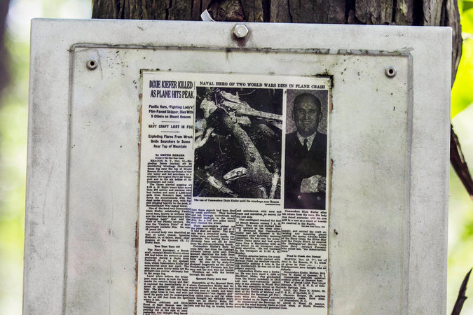

Posted on a tree above pieces of wreckage is a New York Times article from Nov. 13, 1945, about the crash.

CreditHirokoMasuike/The New York Times

At the site, Mr. Rocco has draped large flags from tree branches and stuck small ones into the ground. Over the years, hikers have gathered small parts of the plane wreckage and left them at the base of a tree that bears a small plaque and a laminated newspaper article. Included in the article is a now faded photo of Commodore Kiefer in dress uniform with his arm still in a cast from shrapnel wounds incurred during Japanese kamikaze attacks on the [aircraft carrier](http://topics.nytimes.com/top/reference/timestopics/subjects/a/aircraft_carriers/index.html) Ticonderoga in 1945.

Mr. Rocco, a former carpenter for the New York City Housing Authority, has dedicated himself to drawing attention not only to Commodore Kiefer, but the other servicemen who died on Mount Beacon on Armistice Day in 1945, a predecessor to [Veterans Day](http://topics.nytimes.com/top/reference/timestopics/subjects/v/veterans_day/index.html?inline=nyt-classifier).

Memories of the crash have faded into the domain of local lore and some military buffs, said Mr. Rocco, who hopes to change that. He helped create a group to honor the victims and has led numerous hikes to the site. He has given presentations to local groups and found people with connections to the crash and victims. He is raising funds to have a memorial installed near Mount Beacon’s base.

“Most of all, I just want their story to be told,” said Mr. Rocco, who spent more than three years gathering research material on the crash through libraries, historical societies and government archives.

Mr. Rocco said he attended a reunion of surviving sailors who served under Commodore Kiefer, “and every time I asked them about Dixie Kiefer, tears came down their faces.”

Mr. Rocco is no writer, but in January he happened to pick up a book by [Don Keith](http://www.donkeith.com/), an author in Alabama who specializes in military history and themes. Mr. Keith’s books have been turned into movies, including “Firing Point,” a 2012 submarine thriller that is being made into “Hunter Killer,” a film starring Gerard Butler, Gary Oldman and Billy Bob Thornton.

Mr. Rocco contacted Mr. Keith and interested him in the crash and the story of Commodore Kiefer, a graduate of the Naval Academy who suffered 10 major wounds in the wars.

During the Battle of Midway in 1942, Commodore Kiefer survived the sinking of the U.S.S. Yorktown and was wounded while saving other sailors. During the kamikaze attacks on the Ticonderoga, he ordered the ship maneuvered in a way that saved many lives, even while he was badly wounded. He was also featured in “The Fighting Lady,” a 1945 Academy Award-winning documentary.

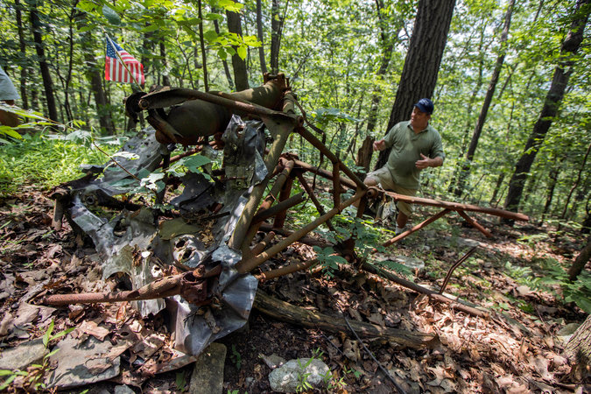

Mr. Rocco near what remains of the Navy plane that crashed in 1945.

CreditHirokoMasuike/The New York Times

Mr. Keith agreed to write a book with Mr. Rocco, who sent him a large box of research material he had gathered. The result is the recently published biography, [“The Indestructible Man: The True Story of World War II Hero ‘Captain Dixie’.”](https://www.amazon.com/Indestructible-Man-Story-World-Captain/dp/1548322598)

Mr. Rocco’s own serendipitous path to memorializing the crash stems from volunteer crusades that included efforts to get an old rail bridge crossing the Hudson River near Poughkeepsie, N.Y., renovated into the [Walkway Over the Hudson](https://www.nytimes.com/2017/04/25/nyregion/walkway-over-the-hudson-state-park-poughkeepsie-day-trip.html?_r=0) pedestrian bridge that opened to the public in 2009.

Afterward, Mr. Rocco turned his sights to renovating the [Mount Beacon Fire Tower](http://blog-tw.nynjtc.org/mt-beacon-fire-tower-newly-restored-is-a-popular-hike-destination/), during which he was told by local residents about two Navy plane crashes on Mount Beacon: the 1945 crash, and one in 1935 that killed two servicemen whose remains have not been found.

Top of Form

One of those local residents was an avid hiker and dentist, Dr. Bill Stolfi, 59, who had come upon the crash site after hiking Mount Beacon for years. Dr. Stolfi began taking people to the site and marking the trail with small flags. He replaced a small wooden marker at the site with the plaque, which is posted under a laminated New York Times article by the Pulitzer Prize winning journalist and columnist [Meyer Berger](http://niemanstoryboard.org/stories/whys-this-so-good-no-17-meyer-berger-mark-johnson/).

The article describes how the six servicemen, after attending an Army-Notre Dame football game at Yankee Stadium, were flying back to the Quonset Naval Base in Rhode Island, where Commodore Kiefer was the commander. The pilot went off course, “obviously lost in the soupy fog,” Mr. Berger wrote.

At the crash site on a recent weekday, Mr. Rocco replaced some of the smaller weathered flags and adjusted the hanging ones. He pulled out two small boxes containing Commodore Kiefer’s Navy medals, which he obtained from a friend of the Kiefer family.

The “indestructible man” was less concerned with medals than the welfare of his sailors, Mr. Rocco said, adding that 240 of Commodore Kiefer’s men rushed from the base to help with the rescue efforts.

After a 15-hour search, Commodore Kiefer’s cap was found along with his charred remains. He was 49.

“There were a lot of bummed-out people when they found out Dixie Kiefer was among the dead,” Mr. Rocco said as he began his labored descent back down the trail blazed by the rescuers.