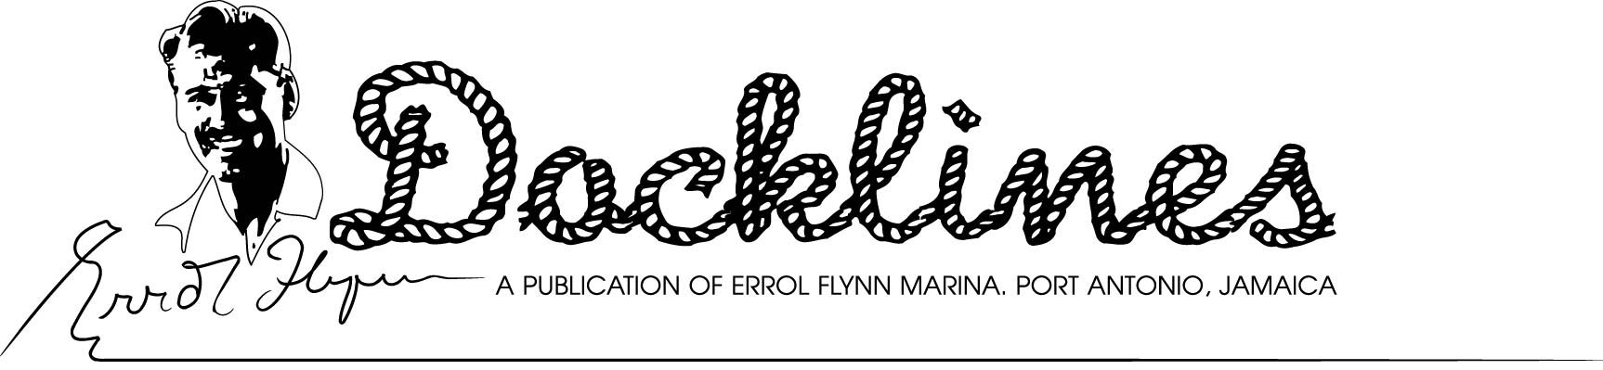
OCTOBER, 2009 EDITION
FLYNN IN AGAIN IN NOVEMBER - It’s being billed as the “event of the year” and will benefit the very deserving Port Antonio Marching Band. It also marks the 100th anniversary of the birth of Screen Legend Errol Flynn plus the 50th year since his death. On Saturday, Nov. 14, some 500 guests will descend on the Errol Flynn Marina’s Cruise Pier to dance to the music of the 50’s and 60’s and reminisce about the days that Flynn brought such an extreme degree of notoriety to the region. The evening will kick off with a parking area demonstration by the Marching Band followed by a cocktail hour from 7 to 8 p.m. featuring selected wine, cheeses and hors d’oeuvres provided by several of the evening’s sponsors. The cocktail hour will feature the keyboard artistry of Peter Stoddart and the jazz/blues voice of Trish Chamberlain. From 8 p.m. until everyone gets tired, Sonny Bradshaw’s “Big Band” will be presenting famous tunes of the era. There will also be a few elegant ballroom dancing demonstrations during the evening. Mrs. Patrice Wymore Flynn, Errol’s widow who resides near Port Antonio, is patron of the evening and her grandson, Luke Flynn will also be in attendance. Luke bears an amazing likeness to his famous grandfather and is also an actor in various action films. During the course of the evening, there will be a giant screen behind the band featuring a continuous series of photos over Flynn’s 50-year lifetime. Only 500 tickets will be sold for the event . Tickets are $5,000 Jamaican dollars each (About $57 USD) and are available at Stewart Auto Sales in Kingston or at the Errol Flynn Marina in Port Antonio. For additional information call 876-477-6914. Beneficiaries of the evening, the Port Antonio Marching Band, is in dire need of both equipment and uniforms. The band presently has a waiting list of more than 60 local youth seeking to join the group.
GOOD NEWS S00N COME - The Errol Flynn Marina’s pool bar, deli/gourmet shop and the formal restaurant will all be up and operating for the 2009-10 season. This is in addition to our Scoops Ice Cream Shop and Norma’s at the Marina Beach Bar and Grille. We will have additional details soon but we can tell you that the deli will be open early for breakfast and will have a sidewalk café atmosphere plus free wi-fi as well. It is also expected to offer gourmet deli items, fine wines and have a provisioning service for yachts and villas alike. The deli/gourmet shop is located in the building formerly occupied by Rum, Roast and Royals. The pool bar (name to be announced) will also have free wi-fi, offer daily special events like “Mojito Mondays”, “Salsa Saturdays”, etc., The formal restaurant will feature both international and Jamaican cuisine in addition to offering catering services. See complete details in our next Docklines edition.

MARLIN TOURNAMENT BEGINS - As this month’s Docklines goes to press, the 46th Annual International Marlin Tournament gets underway with an estimated 30 fishing machines taking to the sea Monday, Sept. 28. One of the Caribbean’s oldest continuous tournaments, the event focuses on “catch and release” to preserve the dwindling numbers of Blue Marlin in our waters. Awards night for this year’s tourney is Friday, Oct. 2, at the Port Antonio Marina on the opposite side of the west harbour from Errol Flynn Marina.
FACILITIES FOR RENT = Several Errol Flynn Marina facilities are available for rental for special events such as weddings, birthdays and even company outings. These include the scenic Ken Wright Pier and Terminal Building in addition to the marina beach and the Port Antonio Marina complex. For complete details, rental rates and applications, contact the marina office at 876-715-6044 or email info@errolflynnmarina.com The marina is frequently the site used for wedding photos, fashion shoots, and music videos.
BOAT SHOW SCHEDULE - The Fort Lauderdale International Boat Show, the world’s largest, will unfold for the 50th time Oct. 29 to Nov. 2 at several venues. Errol Flynn Marina will be in Booth 3078 on the ground floor at the Broward County Convention Center. There is free shuttle bus and water taxi services between the various venues. The marina will also be exhibiting at the Miami International Boat Show at the Miami Beach Convention Center Feb. 11-15, 2010.
COMING EVENTS:
Thursday Oct. 29-Monday, Nov. 2- Fort Lauderdale International Boat Show, Florida
Saturday, Oct. 31 – Red Cross Benefit Concert, Ken Wright Pier, Port Antonio
Saturday, Nov. 14 – Errol Flynn Centennial Ball, Ken Wright Cruise Pier, Port Antonio
DON’T MISS ‘BLUE MONDAY’ - Every Monday is “Blue Monday” at the marina pool bar. Stop by and try some of Peter’s Potent Punch (Jamaican rum that is!) for just one buck and listen to a little jazz/blues provided by some of our local artists that just happen to show up. Don’t have your instrument? No problem! We have a house keyboard and electric guitar on hand as well plus all the amp stuff. Just in case no players or guitar pickers show up, our volunteer DJ (The Incredible Hulk) keeps the music flowing. The bar opens at 5 p.m. From November through May, we have a paperback book exchange as well. Bring a few, take a few.
Errol Flynn Marina and Shipyard
Box 188-Ken Wright Drive- Port Antonio, Portland, Jamaica, W. I.
Tel: 876-715-6044 or 876-993-3209 Fax: 876-715-6033
www.errolflynnmarina.com – email: info@errolflynnmarina.com
VHF Channel 16/9---18⁰11.65’N, 76⁰26.875W – Use DMA Chart 26129 or Admiralty 458 (Recommended)
Opinions Expressed in this Publication are those of the Editor and do not necessarily reflect the opinion of the Port Authority of Jamaica

