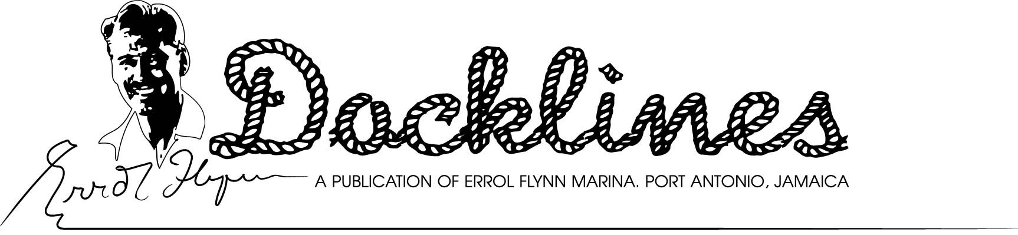September , 2011 – Our 46th Edition
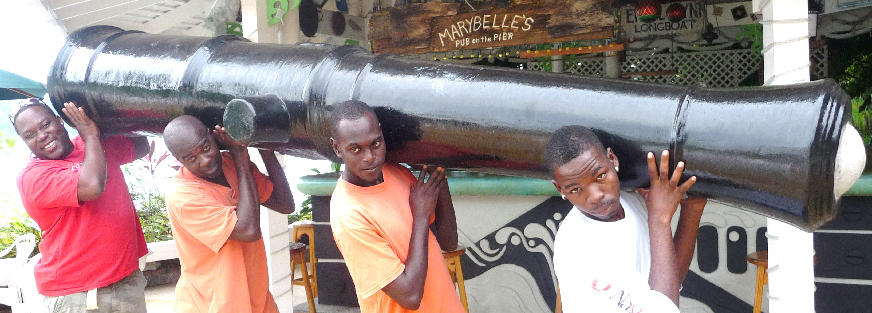NO SCRAP METAL SALE FOR THIS CANNON- Four Errol Flynn Marina dock workers heft a 10-foot-long 17th Century Naval cannon into Marybelle’s Pub on the Pier at the marina. Actually a fiberglass reproduction of the “real thing” that weighed some 5,000 pounds. This duplicate tips the scale at a mere 75 pounds. Grimacing under the cannon’s weight are, from left: Steve Woolery, Cecil Thompson, Tyrone Reid and Trevor Douglas. (Errol Flynn Marina Photo)
SOME REALLY BIG ‘CAT’, IT IS- It’s the largest catamaran yacht to ever visit Port Antonio and for some time it was the world’s largest yacht of its type. The yacht, registered in Dutch St. Maarten, is “Tahuna II” and measures 90 feet long and 45 feet wide. The impressive French-built yacht is temporarily at the Errol Flynn Marina. The yacht is well-known in the Eastern Caribbean where is has been based for many years.
SIX WEEKS TO MARLIN TOURNAMENT- The countdown is now on for the opening of the 48th Annual Port Antonio International Marlin Tournament sponsored by the Sir Henry Morgan Angling Association Oct. 15-22 at the Old Marina. The docks are now being prepared for the big event, including a significant upgrade of the marina’s dockside electrical system; among other improvements. For complete tournament details, contact Chairman Dr. Ron DuQuesnay at 876-909-8818 or rondq@mail.infochan.com.
‘FOLLY LIGHT’ IDEAL SPOT TO VISIT- If you get the opportunity, don’t miss a chance to visit the Folly Lighthouse at the entrance to East Harbour in Port Antonio. It’s a whole lot more than just a lighthouse. Nestled on rough exposed reef for the past 120 years the light has been guiding mariners to Port Antonio. The grounds are also an ideal place to walk and lap up the ocean breezes that never seem to stop. While there, be sure to take the footbridge over to the light and daymark that guide sailors departing the harbour. From this vantage point you will get the best possible view of what is know as “Monkey Island” and is more correctly called “Wood Island”. The light house property was once part of the adjacent old Folly Estate owned by the Alfred Mitchell Family. One of the suitors for one of the Mitchell daughters (Alfreda) was none other than famed explorer Hiram Bingham who in 1911 discovered Machu Pichu, the lost city of the Incas in Peru and brought the monkeys to the island. “Machu Pichu” simply translated means “old mountain” . A small bridge once connected Wood Island with the main estate property. It is recommended that groups call ahead to Lighthouse Keeper Lincoln Ward at 876-447-2703. Oh, yes, don’t forget the camera!
THE OLD CUBA WATCHER- Portland Mayor Floyd Patterson is on a mission to establish closer ties with Santiago de Cuba and expects to send a delegation to the southeast Cuban city in November. Purpose of the mission is to reestablish ties with this second largest city in Cuba and officially re-inaugurate a “Sister City” programme. Portland, which is Port Antonio’s parish, will seek to establish both economic and cultural ties with the Cuban municipality. An earlier attempt to send a delegation in July was delayed to better prepare for the trip. The trip will include a presentation on Portland including various highlights of parish sights, economic opportunities and how the twining of the two cities can mutually expand opportunities for both. It is expected in return that Santiago de Cuba will mount a delegation to visit Port Antonio and Portland early in 2012. The project is gaining momentum with some sponsorship and offer of a private aircraft to take the delegation to Santiago and return. There is also now the prospect of having a small cruise ship operate between Santiago and Port Antonio. More details are expected from the mayor as the trip date approaches. Many yachts cruising the area view Port Antonio as the back door to Cuba. Most visitors to Errol Flynn Marina also include Santiago de Cuba in their itinerary. For additional details on Cuba cruising, consult with one of our staff members.
MOORING/ANCHORING RATES, BEST DEAL YET- For just 10 bucks (US$) a day, to use our anchorage, here’s what you get: --The safety of one of the best anchorages in the Caribbean, bar none. Use of our new dinghy dock where you don’t need to climb a steep wall to get ashore. Then to top this don’t forget about the free wi-fi, use of the marina pool, beach, showers, toilets and laundry plus the outstanding security and friendliest marina staff you can find. Port Antonio is a superb hurricane hole. As most hurricanes originate in the east, a tropical storm has to pass over not one, but two mountain ranges before reaching Port Antonio. The harbour is further protected by 64-acre Navy Island and a significant barrier reef that shelters it from any heavy weather approaches from the north and northwest.
$262.50 HAULOUT/LAUNCH FOR 35’ YACHT- A haulout and launch on our Marine Travelift for a 35 foot yacht is just $US262.50! Some other rates are: 40 foot: $300.00/50 foot:$375.00/ 60 foot:$450.00/70 foot:$525.00. That’s only $7.50 per foot both ways!
To arrange a haulout, contact George Munro, operations manager. At 876-715-6044.
ABOUT THOSE CRIME STATISTICS! While we acknowledge that St. Maarten and Antigua are the undisputed centers of Caribbean yachting activity (at least for now), we fail to understand the crime statistics for Port Antonio and this area, always being ignored in the mainstream marine press. Our parish, Portland, not only has the lowest crime rate in Jamaica, but the entire Caribbean! Want to know more? Just Google “St. Maarten Yacht Crime” or “Antigua Yacht Crime” etc. Is Port Antonio the safest yachting area of the Caribbean? We think so! Oh, we forgot to confess that there was a pair of Topsiders that went missing on the main dock last season. We’re still pursuing the perp!
BILL BLIGH WAS HERE! - Probably one of the most maligned sailors of all time is Capt. William Bligh, who also has a special association with Port Antonio where he introduced breadfruit from Tahiti to our island. This was actually in the early 1790’s; a few years following his tour on the HMS Bounty and his amazing 3,700 mile journey to Timor in a longboat after he was put adrift by Fletcher Christian and the mutineers. Although Bligh was not the vicious man portrayed often in movies and fiction, many claim his over-sensitivity and acid tongue damaged what would have been otherwise a distinguished naval career. Bligh’s landing in Jamaica was commemorated by a large mural in one of abandoned hotel buildings on Navy Island here in Port Antonio; a popular exploration venue for many of our visitors. We will periodically be tossing a few tidbits here and there about a few of the famous names that have graced our shores. Bligh also brought the Tahiti Apple, a bright red pear shaped fruit that is ultra tasty served sliced and cold. Below is another mural which originally graced the Jamaica Reef Hotel and is now believed to be adorning some unknown villa in Jamaica.
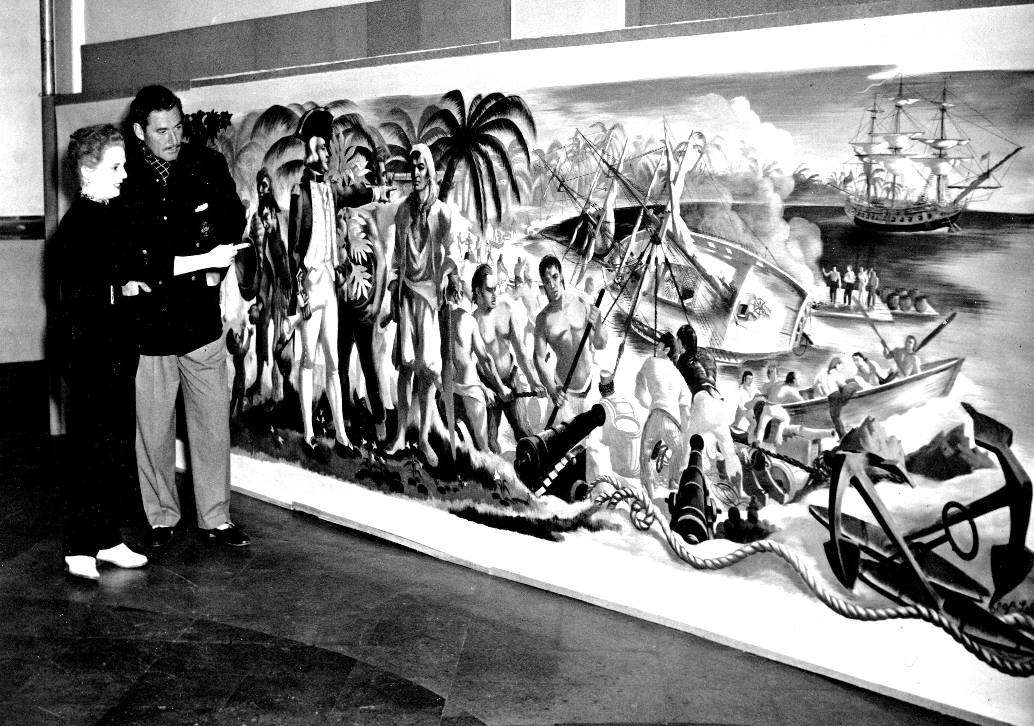MISSING MURAL-This magnificent mural, depicting the arrival of Capt. William Bligh in Port Antonio with the breadfruit from Tahiti adorned the Jamaica Reef Hotel when it was owned by Errol Flynn. (above). It further depicts the careening of a ship for bottom service on Navy Island, along with other historical events. The mural was removed from the hotel during a fire and its whereabouts today have long been the subject of controversy. Olga LLehman (left) is the muralist.
Errol Flynn Marina and Boatyard
Box 188-Ken Wright Drive- Port Antonio, Portland, Jamaica, W. I.
Tel: 876-715-6044 or 876-993-3209 Fax: 876-715-6033
www.errolflynnmarina.com – email: info@errolflynnmarina.com
Opinions Expressed in this Publication are those of the Editor and do not necessarily reflect the opinion of the Port Authority of Jamaica

