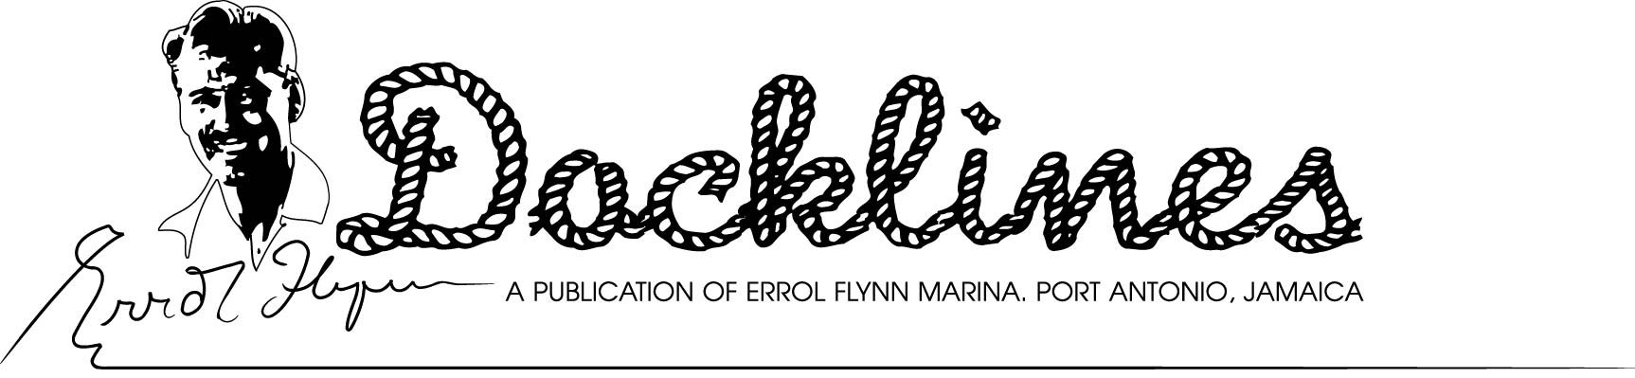August 2010, 33rd Edition
ERROL FLYNN BALL TO AID HOMELESS- This year’s Errol Flynn Benefit Ball will provide funding for Portland’s homeless rehabilitation shelter. The semi-formal event is scheduled for Saturday, Nov. 13, at the marina’s Ken Wright Pier, according to Diana Stewart, chairman of the annual event. Launched in 2009, the 100th anniversary of Errol Flynn’s birth, the primary goal of the annual ball is to provide significant funding each year to a worthy Portland Parish charity, Mrs. Stewart emphasized. Errol’s widow, Mrs. Patrice Wymore Flynn, also of Portland, is patron of the event. The event will again feature a lighted, changing colour dance floor, the Sonny Bradshaw Big Band and the soft stylings of Jamaican songstress Myrna Hague. Mrs. Karen Sangster is co-chairman, Lennon Crooks is show producer and Dale Westin is marina liason. Only 300 tickets will be sold for the ball. Tickets at $6,500.00 Jamaican dollars (USD$77.00) also include an extensive buffet dinner and complimentary drinks throughout the evening. As in 2009, there will also be a number of high-ticket door prizes donated by key Jamaican businesses. Tickets are available at Stewart’s Auto Sales in Kingston (876-926-0931) and at the Errol Flynn Marina in Port Antonio (876-715-6044).
.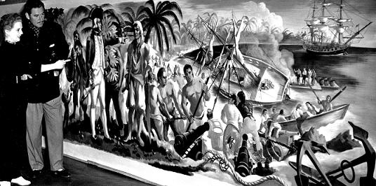
GONE, BUT NOT FORGOTTEN- The mystery of what happened to the massive mural of Captain Bligh’s landing in Jamaica with the breadfruit. Executed by famed British Muralist Olga Lehman (seen here with Errol Flynn), and gracing the Titchfield Hotel in the early 1950’s. It is rumored the mural was removed during a fire that destroyed the hotel, but its whereabouts have long been a topic of discussion and controversy among Flynn fans. (Photo Courtesy Errol Flynn Blog)
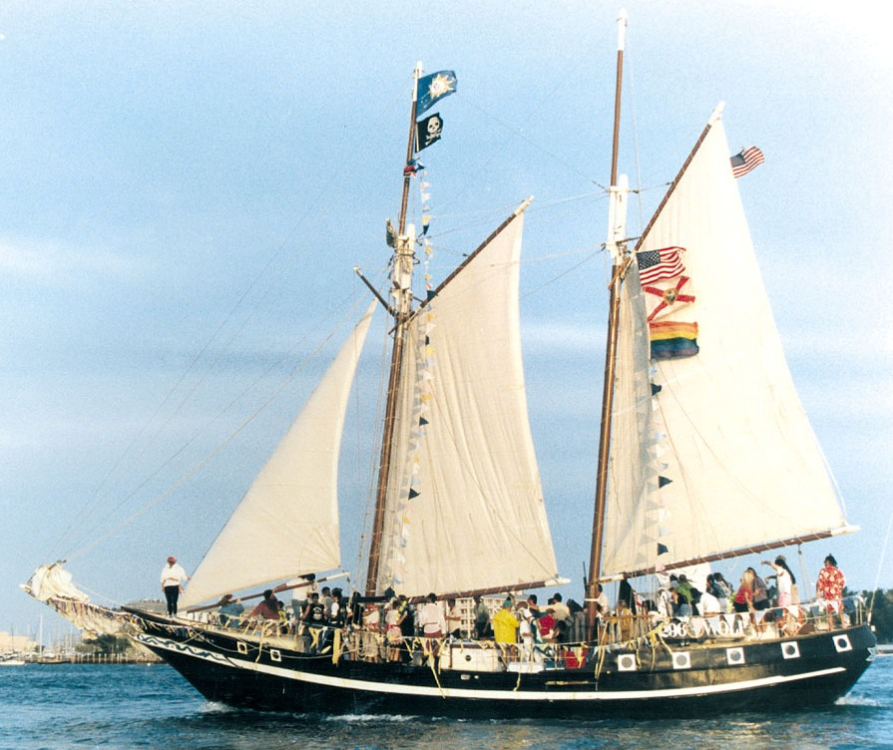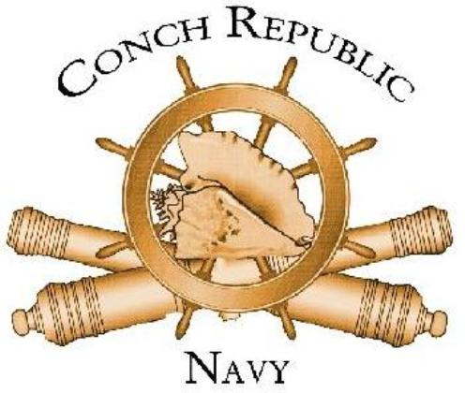
TOPSAIL SCHOONER ‘WOLF”
THE YANKEES ARE COMING, THE YANKEES ARE COMING!!! – That’s the word received from the Conch Republic Navy First Sea Lord himself! To be known as the “Conch Republic Navy Flotilla Sail Along” to Port Antonio Dec. 9, the flotilla is designed to introduce a new generation of sailors to the Caribbean and Jamaica. Led by Admiral Finbar’s 74’ topsail schooner “Wolf”, the flotilla departure from Key West, Florida will follow several days or intense orientation (and appropriate partying) to introduce first-time passage makers to the rights and wrongs of such a trip. Goal is to attract 50 yachts to this “first” for Jamaica. The “flotilla” concept was pioneered some years ago and presently attracts hundreds of both seasoned and neophyte sailors to the British Virgin Islands (Carib 1500). The pre-departure seminars are not only designed to insure all participants have both the sailing experience and are properly equipped for the voyage but also to instill confidence in each participant needed for an uneventful passage. Participants in flotilla groups also like the peace of mind of always having another yacht in proximity if help is needed. The preliminary seminars and parties are all geared to get the spirit of camaraderie in the forefront from the getgo. The flotilla organizers will be working closely with the Jamaica Tourist Board and a number of sponsors to “roll out the red carpet” for the flotilla’s arrival in Port Antonio, tentatively set for Dec. 21-23. The flotilla will make a two to three stopover at Georgetown, Exumas , in the Bahamas before the final leg to Jamaica. More details will be announced as the event approaches. For information on registering for the flotilla, call 305-296-0604 or email sailaway@schoonerwolf.com.
ABOUT THAT PLACE CALLED ‘CONCH REPUBLIC’ With a motto like “We seceded where others failed” the Conch Republic stands as a symbol of Yankee spirit and independence. The Conch Republic was established by”secession” of the Florida Keys from the United States of America, on April 23rd, 1982 in response to a United States Border Patrol Blockade setup on highway U.S.1 at Florida City just to the north of the Florida Keys. This act effectively isolated Keys Citizens from the U.S. mainland since the blockade was on our only land artery to and from the mainland. This roadblock portrayed Keys residents as non-U.S. citizens who had to prove their citizenship in order to drive onto the Florida mainland!
LIKE, WE’RE A ‘CLEAN MARINA’ PLUS SOME- We’re pleased to let our readers know that Errol Flynn Marina has been named as a “Blue Flag Marina” for the fourth consecutive year! What does all that mean? First, our marina is only one of six with such a distinction in the Caribbean. If you’re familiar with the USA’s Clean Marina programme, “Blue Flag” is a clean marina rating system and a whole lot more. Largely a European –originated marine eco programme, it rates marinas by the impact they have on the ecology; hence those with the least impact, rate highest. A new “Blue Flag” information board has been posted near the marina dock entrance which details the programme to our visitors and our flagpole is of course proudly displaying the “Blue Flag”.
IT’S NICE TO BE INCLUDED! It is nice to see that a significant number of websites around the Caribbean and the World like our “Docklines” enough to include the issue each month on their own websites. These include, www.allatsea.net and www.errolflynnblog.com, among a multitude of others. An “Errol Flynn Docklines” Google search comes up with 1,240 results. We are also are extremely pleased that a substantial amount of Docklines is reprinted monthly in Jamaica’s Gleaner newspaper’s “Hospitality Jamaica” section.
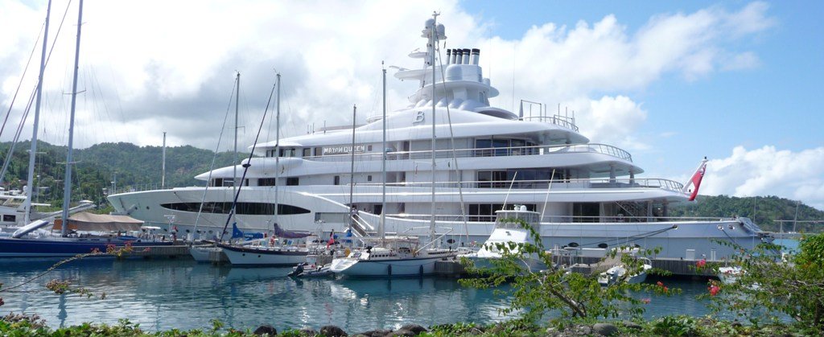
NOBODY HANDLES THEM ANY BIGGER-In the Caribbean at least. At 306’, Mayan Queen IV dwarfs the yachts in the forefront. However, Errol Flynn Marina is capable of handling any vessel more than twice Mayan Queen’s size (actually up to 660’) and docking it alongside. Further, there is sufficient space in the marina to completely turn a vessel that size. (Errol Flynn Marina Photo)
TRANSCARAIBES RALLY RETURNS IN 2011 - We must be doing something right! Transcaraibes Rally organizers have confirmed with marina management they will return to Port Antonio for the third consecutive year April 16-19 in 2011, according to Stephane Legendre, organizer. The event originates in the French Department of Guadeloupe in the Eastern Caribbean and includes stops at Saint Martin, Dominican Republic, Haiti, Jamaica, and Cuba. The rally encompasses the period of April 2 to 22. For rally details, entry forms check out www.transcaraibes.com or email to polypat.caraibes@wanadoo.fr “Vive la France!”
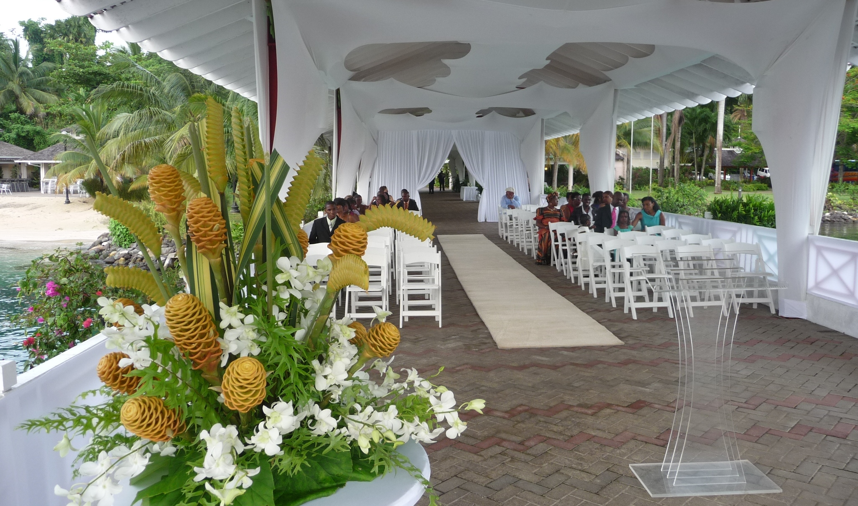WEDDING BELLS RING ON PIER- This wedding chapel created by decorators on the marina’s Ken Wright Pier illustrates the magical beauty of one of many such events now scheduled at the marina. Marina facilities are available for all types of event rental including concerts, seminars, family reunions, fundraisers, and yes, weddings too! (Errol Flynn Marina Photo)
TRACKING DEVICE YIELDS STOLEN YACHT- A 2008 model 37’ Beneteau sailing yacht, stolen from a British Virgin Islands charter company, was seized near Port Antonio by Jamaica’s Coast Guard and the two thieves on board arrested and jailed. It was learned that the thieves, one USA and the other a BVI citizen, had planned to sell the yacht at a price considerably below market value, to a Jamaican buyer. The seizure came about through a coordinated effort of the BVI and U.S. Coast Guard-Jamaica Defense Force Coast Guard following the vessel’s hidden tracking device and working in concert to apprehend the thieves. The vessel was brought to Errol Flynn Marina by authorities pending return to the rightful owners. The Nav-Tracker GPS Tracking System keeps owners or captains informed of a boat’s location through a GPS tracking service using the Inmarsat satellite network. The system sets a 500 Meter geo-fence (radius) around the vessel when armed. In the event of geo-fence breach or if any of the optional sensors go into alarm mode, the system will send emails or text messages with latitude, longitude, speed and heading. It will continue to send messages until the vessel returns to the geo-fence area, or the system is disarmed. Optional sensors include door contacts, infrared beam sensors, deck pressure sensors, engine removal sensors and high water sensors. For more information visit www.paradoxmarine.com
COMMUNITY INVOLVEMENT- We strongly believe in being involved in various aspects of our community and support that by having representatives in the Greater Portland Chamber of Commerce, the Portland Chapter of the Jamaica Hotel and Tourist Association, plus the Port Antonio Marching Band Association.
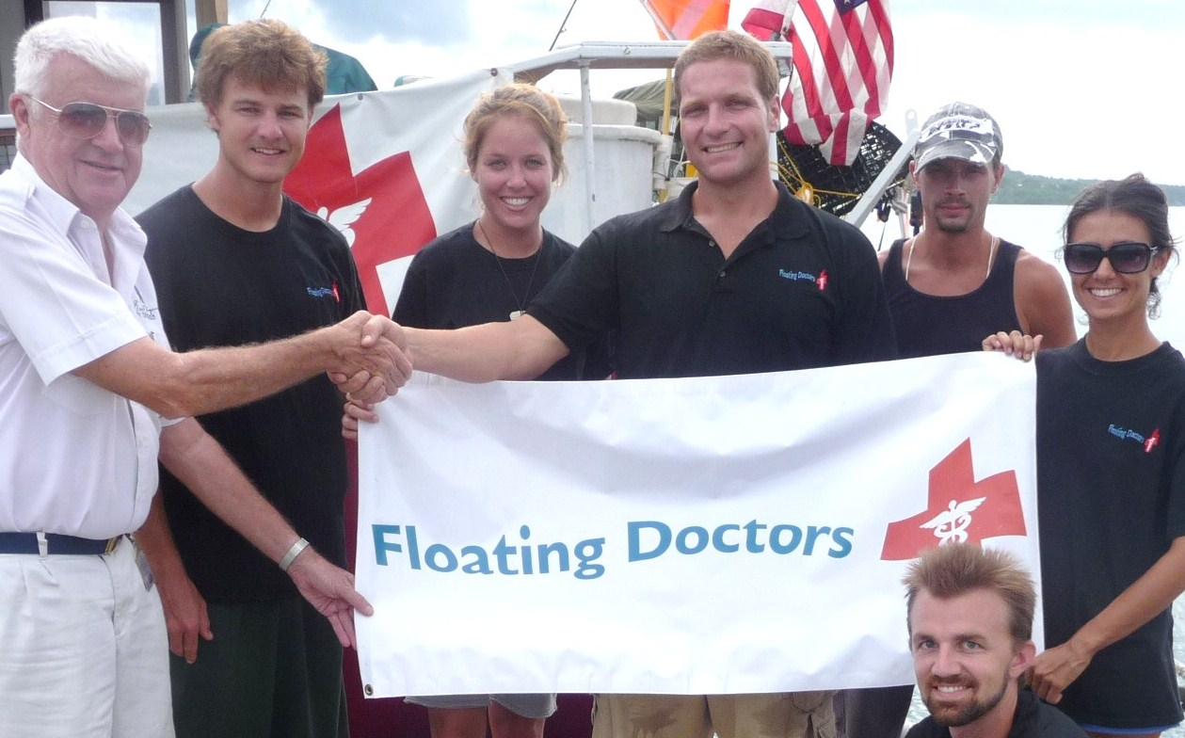
WE’VE BEEN PROUD to play host to an almost continuous flotilla of volunteer vessels that have assisted in the Haitian relief effort in various ways. Above, crew of the Floating Doctors get a warm welcome from Marina Manager Dale Westin, following their four month stint in Petit Goave, Haiti. (Errol Flynn Marina Photo)
‘FLOATING DOCTORS’ VISIT MARINA – Following a four month stint in Petit Goave, Haiti, performing some intense construction and clinic work, we were pleased to have the Floating Doctors as our temporary guests on the Errol Flynn Marina docks. This is another in a long procession of volunteer yachts from the USA that have made the Haiti trip since the January earthquake and given generously to our less fortunate neighbors to the east. Errol Flynn Marina is proud to have played a small role in this relief effort by providing a location for some very weary workers to get some well-deserved R & R after their Haitian ordeals. It’s amazing the comments we get from the crews on their arrival here: “…at last! Real sidewalks, even streets…and sit-down toilets too, and warm running water too!” are just a few of the expressions we’ve heard. Want to be really thankful for what you’ve got? Just spend a few days in Haiti with one of these heroic volunteer groups!
CHAMBER SEEKS RENEWED CUBA TIES- Reestablishing previous ties with nearby Santiago de Cuba was a lively topic of discussion at a July 15 Portland Chamber of Commerce meeting in Port Antonio. The group, seeking to revitalize it’s impact on the Portland business environment, previously had the Cuban southeast port town as it’s “Sister City”. The group is also seeking to reinstate the passenger ferry service that operated through 2002 between Port Antonio and Santiago, according to Chamber President Fred DeTroy, and will be actively seeking a serious operator.
EMANCIPATION/INDEPENDENCE WEEKEND ‘TO- DOS’- It’s that time of the year again when we take a little time off to celebrate our “ freedom from those colonial shackles.” At least that’s what the new history books are saying. From Friday, July 30, through Sunday, August 8, will pretty much be down time in Jamaica. Emancipation Day is actually Sunday, Aug. 1 but will be officially observed Monday, Aug. 2. Friday, Aug. 6, is Independence Day. It seems a lot of folks are expecting the three days in between Emancipation and Independence days to be pretty much holidays as well. There will be a lot of activity in the Port Antonio area. Here’s a sampling:
Friday, July 30/Saturday, July 31 – “Brutus & Friends” Live Jazz Combo, Rusalka Restaurant, Errol Flynn Marina, 7 p.m. to ?
Saturday, July 31 – Live poolside music, Fern Hill Club, San San Area.
Sunday, Aug. 1– Frenchman’s Cove Beach Party, San San Area
Monday, Aug. 2 – Blue Monday at Marybelle’s Pub on the Pier, live entertainment, Errol Flynn Marina Pool Bar including $1.00 rum punch, $2.00 beers.
Friday, Aug. 6 – Independence Day Jam Session, DeMontevin Lodge, Titchfield Hill, Port Antonio
--Long Bay Street Gala – All Day parade, street entertainment, free entry
Saturday, Aug. 7 – Country Fair and Art Exhibition, Hotel Mocking Bird Hill.
-- Great Huts, Boston, African Drumming and Dance Exhibition, 7 p.m.
Sunday, Aug. 8 – Winifred Beach Party featuring the Manchioneal Dancers
The week’s activities also include rafting on the Rio Grande, and visiting key Portland attractions including Reach and Somerset Falls, the Maroons area at Charles Town plus hiking or biking tours throughout Portland Parish.
PORT ANTONIO INVESTMENT OPPORTUNITIES – Several properties of the Port Authority of Jamaica located in Port Antonio are available to suitable investors, including 64 acre Navy Island, Boundbrook Wharf, former Jamaica Railway lands, Boatyard and Titchfield property currently occupied by the Jamaica Defense Force. Inquiries on submitting proposals for these can be directed to the Errol Flynn Marina General Manager Dale B. Westin 876-477-6914 or email to dwestin@portjam.com

Errol Flynn Marina and Shipyard
Box 188-Ken Wright Drive- Port Antonio, Portland, Jamaica, W. I.
Tel: 876-715-6044 or 876-993-3209 Fax: 876-715-6033
www.errolflynnmarina.com – email: info@errolflynnmarina.com
VHF Channel 16/9---18⁰11.65’N, 76⁰26.875W – Use DMA Chart 26129 or Admiralty 458 (Recommended)
Opinions Expressed in this Publication are those of the Editor and do not necessarily reflect the opinion of the Port Authority of Jamaica

